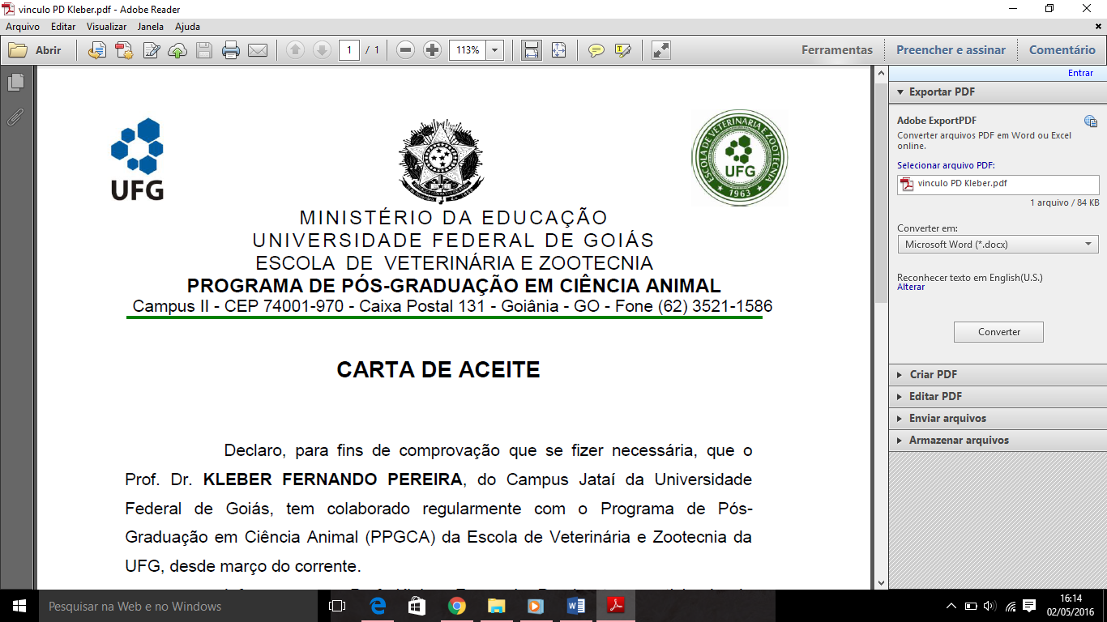

MINISTÉRIO DA EDUCAÇÃO

UNIVERSIDADE FEDERAL DE GOIÁS - REGIONAL JATAÍ

**PROGRAMA DE PÓS-GRADUAÇÃO EM BIOCIÊNCIA ANIMAL**

**SOLICITAÇÃO DE CRÉDITOS POR ATIVIDADES COMPLEMENTARES**

# Jataí, ______ de _____________________ de 20__

Senhor(a) Coordenador(a),

Eu, ______________________________________________________, solicito de V.Sa. as providências necessárias para atribuição de créditos por atividades complementares, conforme documentos comprobatórios em anexo e normativa 01/2018 do PPG Biociência animal

As atividades realizadas foram:

________________________________________________________________ ____________________________________________________________________________________________________________________________________________ ____________________________________________________________________________________________________________________________________________ ____________________________________________________________________________________________________________________________________________ ____________________________________________________________________________________________________________________________________________ ____________________________________________________________________________________________________________________________________________ ____________________________________________________________________________________________________________________________________________ ____________________________________________________________________________________________________________________________________________

Obs.; este formulário deve ser entregue uma única vez 60 dias antes do exame de qualificação.

Atenciosamente,

______________________ _______________________

## Assinatura do Orientador Assinatura do aluno(a)

### Para uso da comissão de bolsas e acompanhamento discente, em reunião realizada em ____/____/____ e homologa pela CPG em reunião realizada em ____/____/____

_____________________________

Assinatura